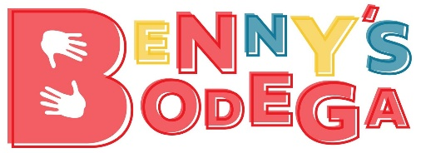 | 166 Spring St., Newton, NJ 07860  973-531-7582  bennysbodega@gmail.com

YOU MAKE A DIFFERENCE
Benny’s Bodega is a non-Profit organization that operates fully off of community donations. With no government funding the Bodega stays open because of businesses and individuals like yourself!!
The Bodega, set up like a store, provides hard working families with a hand up. With proof of employment families are able to come in and shop for basic needs items (food, clothing, cleaning and hygiene supplies) free of charge twice a month. Our mission it to help provide the struggling working families with the help they need to get ahead in life but we understand some people are medically unable to work, so we also offer assistance to senior citizens and people on disability.
With your help we can continue to provide for these families.
YOU DO Make a difference.
Located in the center of spring street, with beautiful glass windows, we are now putting together our BODEGA WALL OF FAME!!! As a wall of fame sponsor, EVERYONE will see a custom-made plaque with your name on it showing that because of YOU the Bodega doors stay open to serve our community!!!
________________________________________________________________________________
YES- ADD ME to the Bodega Wall of Fame for one year
Name to be displayed on the plaque _________________________________________
Circle One- Proud Supporter OR Legacy Donation
$1,000.00 Donation enclosed- Check #________
Sign me up for a $100.00 reoccurring donation each month
Credit Card #_____________________________________ Exp_________ CSV__________
on month 10 your plaque will be created
NO- Unfortunately I can not assist at this level at this time, But I Love what you do- Please accept my
BODEGA BUDDY Donation at this time!!
Amount_________________ Check#______________
Sign me up for a $____________reoccurring donation each month
Credit Card #_____________________________________ Exp_________ CSV__________
Thank you for your time and support

Benjamin Davey, LCSW

